Self-Evaluation Test. Roskin et alii Political Science. An Introduction.

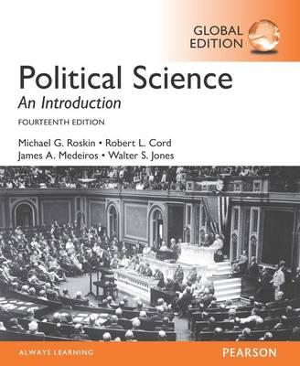

**Ch 9 Politics, the Media and Political Communication**

What is the difference between elite media and popular media?

What is investigative journalism?

What are the consequences of social media for politics?

What is the bounce back effect?

What was the role of social media in recent US elections?

How do contemporary authoritarian regime use modern propaganda tools?

How did television change political communication?

What is framing?

How does the political partisanship and the ownership of the media changes political communication?

Franklin D. Roosevelt won popular support for his policies through __________.

a. weekly radio addresses

b. televised debate victories

c. backroom power brokering

d. numerous personal appearances

What is the relationship between education and media consumption?

a. Education is largely uncorrelated with media consumption.

b. The more educated individuals are, the more media they tend to consume.

c. The more educated individuals are, the less likely they are to read newspapers.

d. Education tends to make people skeptical of getting information from the mass media.